**MOCK SET I EXAMINATIONS 2019**

**Uganda Advanced Certificate of Education**

GEOGRAPHY

**P250/1**

**2Hours 30Minutes**

**INSTRUCTIONS TO CANDIDATES**

* *Answer* ***four*** *questions.*
* *Section* ***A*** *is compulsory. At least* ***one*** *question should be answered from section* ***B*** *and* ***one*** *question from section* ***C****. Credit will be given for the use of diagrams and specific examples*

**SECTION A:**

1. Compulsory map-work question.

Study the 1:50,000 UGANDA MAP Extract of APOKA, sheet 9/3, series Y732

Edition 3 – D.O.S, and answer the questions that follow;

1. Draw a cross section of the area along Northing 06 from Easting 67 to 74 and on it mark and name;
2. Ridge
3. Lowland,
4. River Kalukiling,
5. Settlement
6. Dry weather road (9 marks)
7. Calculate the
8. Amplitude and
9. Vertical exaggeration

of the cross section drawn (2 marks)

1. (i) Describe the drainage pattern followed by river Kalukiling (2 marks)

(ii) Account for the drainage pattern identified above (3 marks)

1. (i) Describe the relief of the area. (3 marks)
2. Describe the relationship between relief and drainage in the area shown on the map extract. (4 marks)
3. Compulsory photograph question.

Study the photograph given and answer the questions that follows:

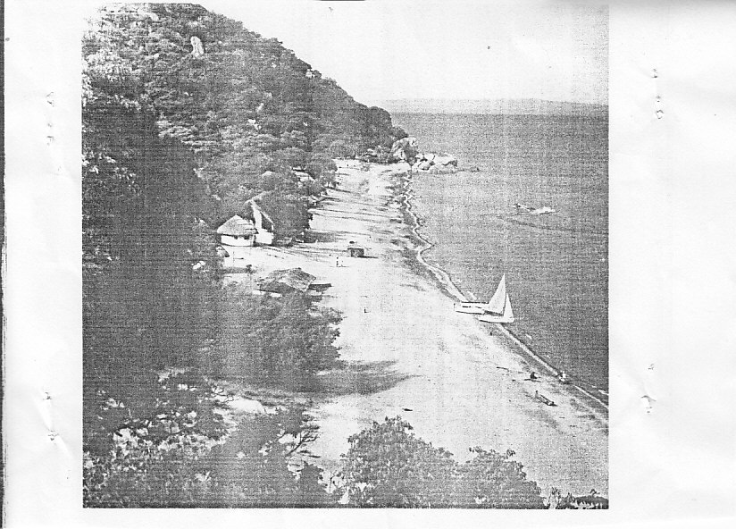

1. Draw a landscape sketch of the area and on it mark and name any
2. Two relief features
3. Two landuse types,
4. One drainage feature (9 marks)
5. Account for the formation of the relief feature found in the central middle ground.

(4 marks)

1. Explain the;
2. Importance of the drainage feature shown in the photograph (5 marks)
3. Problems faced by people living in the area. (5 marks)
4. Giving evidence from the photograph, suggest one area in East Africa where the photograph could have been taken. (2 marks)

**SECTION B:**

1. To what extent does Wegners theory of continental drift explain the present day distribution of continents and ocean basins? (25 marks)
2. Account for the formation of;
3. Metamorphic rocks (12 marks)
4. Sedimentary rocks

in East Africa (13 marks)

1. To what extent does relief influence chemical weathering processes in East Africa? (25 marks)

**SECTION C**

1. (a) What is meant by the term prevailing winds? (5 marks)

(b) To what extent do prevailing winds influence the climate of East Africa? (20 marks)

1. Account for the dominance of the Savanna grassland type of vegetation in East Africa. (25 marks)
2. Describe the processes of zonal soil formation in East Africa. (25 marks)

**END**